1. Taxes on Purchases Should Be User-Added:

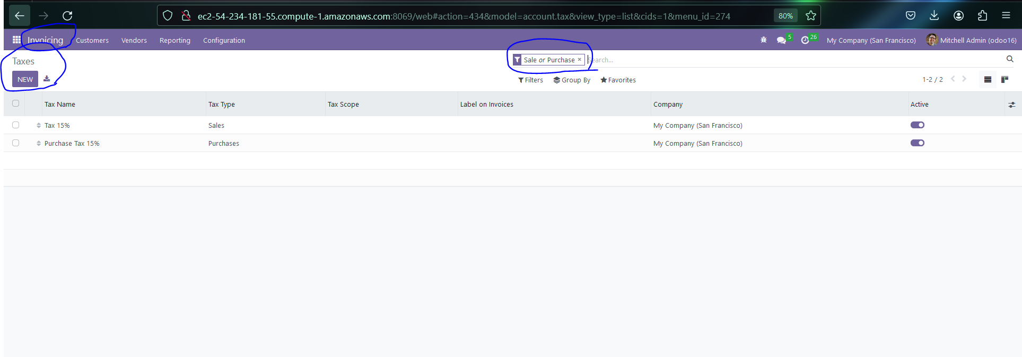

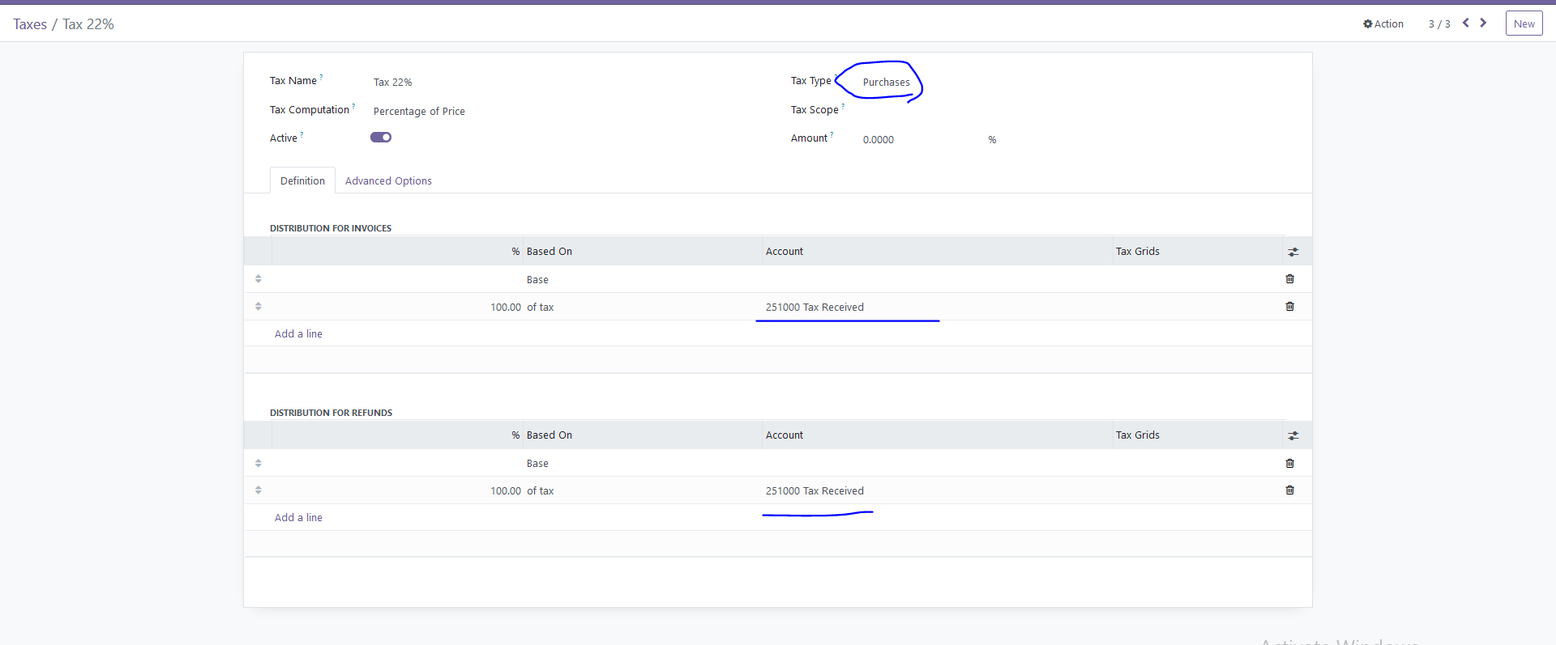

* For setting the default tax, adhere to the steps outlined in these figures: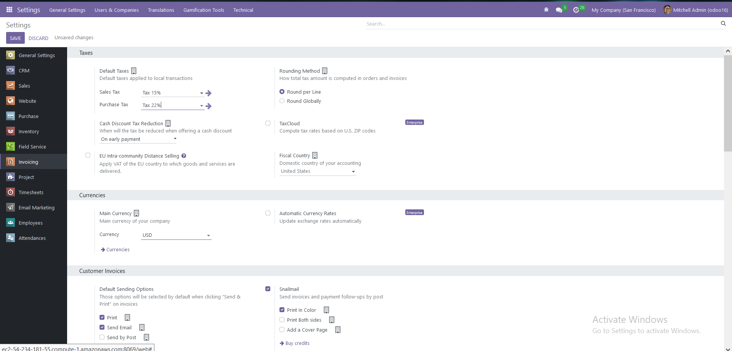
* Modify the Tax on Purchases in the Purchase Order: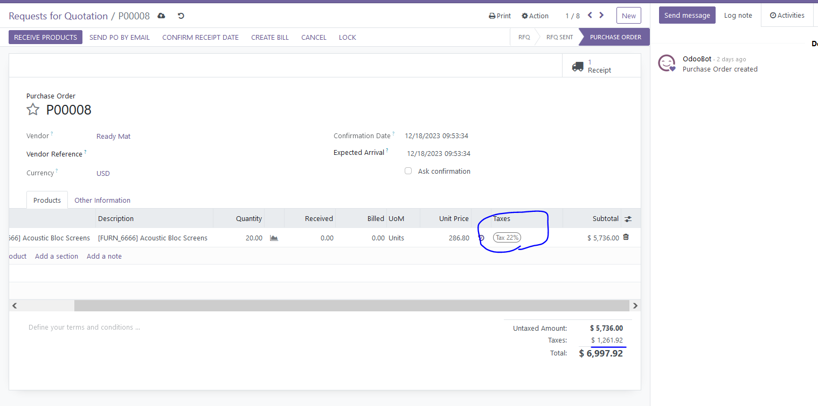

1. Purchase Order - > User should type Deliver to:

* Select Inventory, then navigate to Configuration followed by Operations

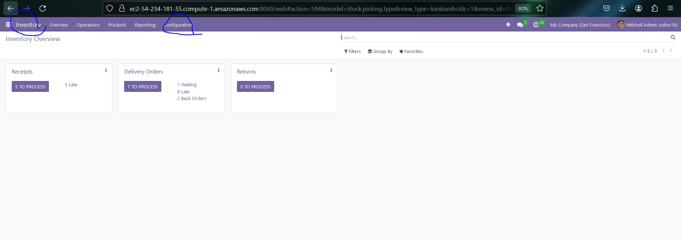

* Create a New Delivery Operation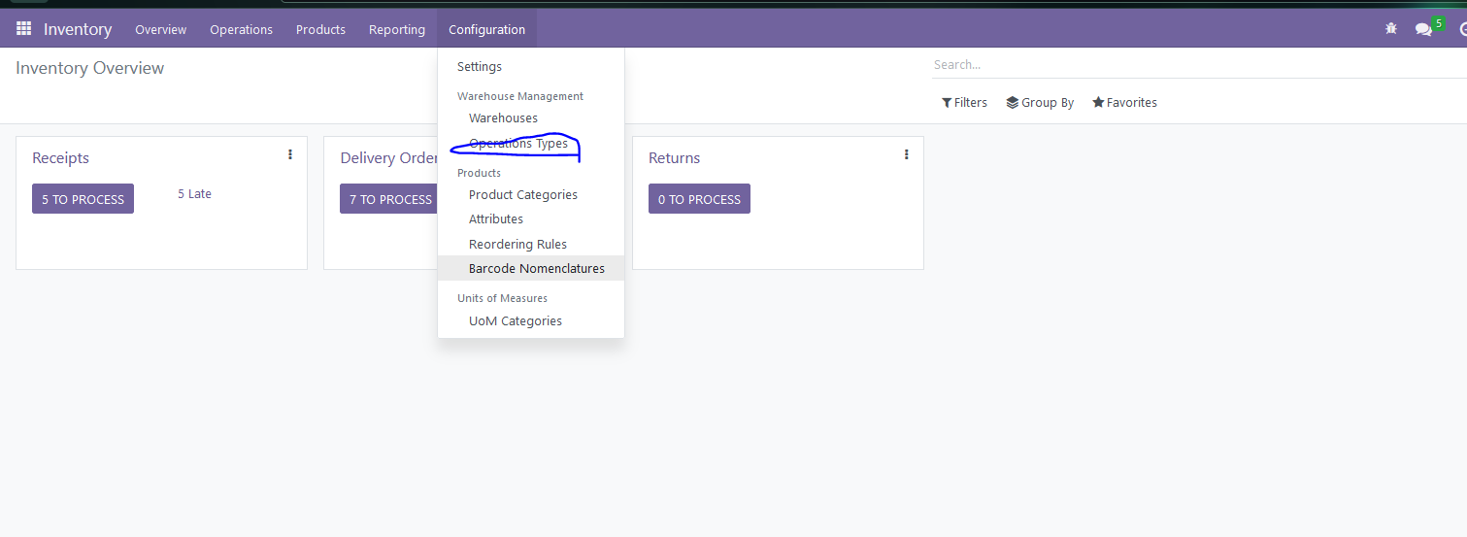

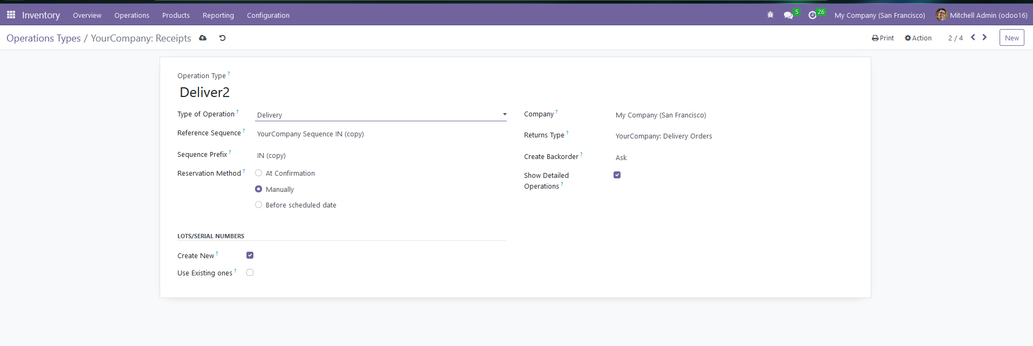

1. RFQ > email send

* Alredy Handed Over to Zaheer

1. Validation error : PO > Create Bill User Error - Purchase>Create Bill >

You just need to set the Bill due date.

1. Logo icon adding in vendor bills or any other bills:

* I will investigate this.